The VuGraph Column
Written by Roger Pfister http://RogerPf.com/aaBridge
Go to the aaBridge Welcome page. Clicking on the Home (house) icon in the top left hand corner will get you there.
In the left hand column click on VuGraph Column that page will now show.
Follow the instructions on that page. (You will be looking at a session from the
1957 Bermuda Bowl). It will show the normally hidden VuGraph Column.
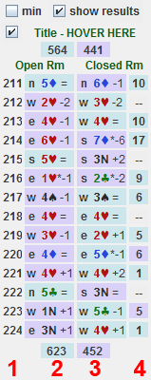
- A VuGraph column consists of four sub-columns in the image on the right numbered shown as 1 2 3 4. All FOUR columns are clickable.
- The first column shows the board number. Clicking on it (Try It) takes you to the start of the deal in the Open Room.
- The central two columns show the contract and result. The color is that of the declarers team. Clicking on either contract takes you into the deal for THAT room, Open or Closed and does an "Enter the Deal" (Try It).
- You can hide the results in the two central columns using the check box at the top of the column, (Try It).
- The fourth column shows the IMP score for that board. Clicking on it (Try It) tales you to the start of the deal in the Closed Room, even when scores are hidden. The color is that of the winning team.
- The first check-box at the very top of the column will minimize the whole column (Try It) and the one below (as was just said) lets you hide the running IMP scores.
- The sessions opening scores are shown at the top and the closing scores at the bottom.

You can google BBO VuGraph Archives and get to the archive site of Matches shown on VuGraph.
The Download link for each match will get you the lin file to Drag & Drop into aaBridge.

<end of document>

